03/01/2017
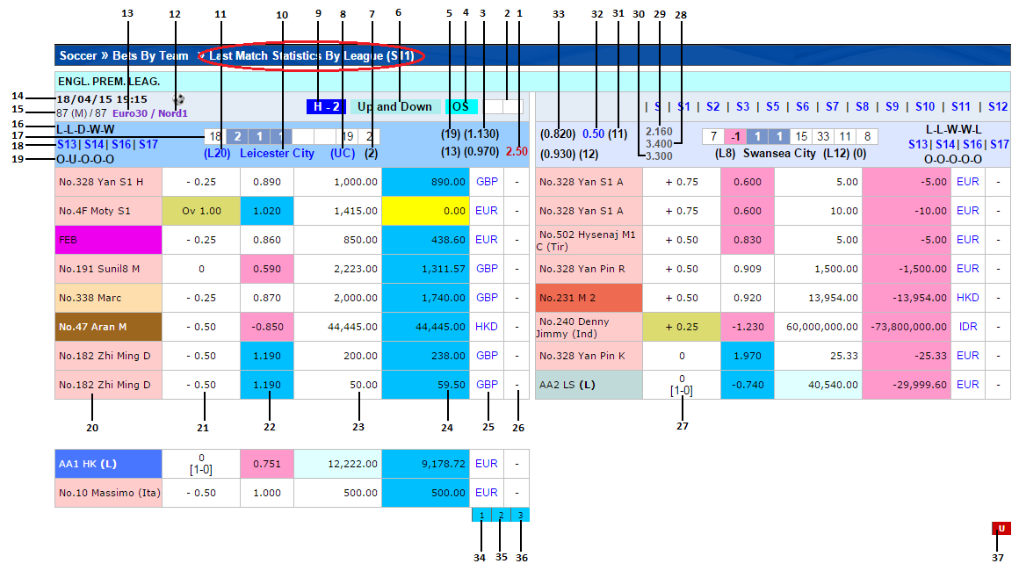
- Description: This is the report displaying statistics for a match for both the teams which played in the same league. This report is for the last match when A team played as home or B team played as away.
# | Header | Info
1,3,32,33 | - | Explained in MSI - 03
2,4,6,9 | - | Explained in MSI - 02
5,31 | - | Explained in TSI - 03
7,8,10,11,17 | - | Explained in TSI - 02 & 03
12,13,14,15 | - | Explained in MSI - 01
16,18,19 | - | Explained in TSI - 01
28,29,30 | - | Explained in MSI - 02
20 |  | Punter (Smart Group) Code
21 |  | Handicap given to the team A
22 |  | Price
23 |  | Stake
24 |  | Win/Lose
25 |  | Currency
26 |  | Smart Group last 12 days performance
27 |  | Handicap team B
34 |  | Handicap Trend (Blue if npricecolumn <= 3 else Dark Blue)
35 |  | Handicap Trend
36 |  | Handicap Trend
37 |  | Over/Under Trend (If TrendType is OverUnder then Red)

How to calculate nPriceColumn:
In Trend setting constants are assigned with the following values in cc_object.js
Trend Settings | Handicap | Over/Under
Spread | 0.075 | 0.1
MovePoints | 5 | 7.5
BreakPoints | 20 | 20

Calculation of Trend Info (calculateTrendInfo()) actually generates three values (nPriceSide, nPriceColumns, nBreakPoints) in the method which will be used in the ccht_object.js to build the trend table.
nbreakPoints is 20 for both HDP and Over/Under as shown in the above table.
To calculate nPriceSide and nPriceColumns, following data is required from the match statistics:
dBetPrice - Price for that bet type. This gets convereted to HK or to other currency based on the oddstypeId.
nselectionId-Selection of the team.
aopenPrice- Opne price for A team
bOpenPrice- Opne price for B team
Condition:
if (nSelectionId == 1)
if(dBetPrice > aOpenPrice)
-nPriceSide = 2;
-dBetPrice = dBetPrice – aOpenPrice;
if (dBetPrice < aOpenPrice)
-nPriceSide = 1;
-dBetPrice = aOpenPrice - dBetPrice;
if(nSelectionId == 2)
if(dBetPrice > bOpenPrice)
-nPriceSide = 1;
-dBetPrice = dBetPrice – bOpenPrice;
if(dBetPrice < bOpenPrice)
-nPriceSide = 2;
-dBetPrice = bOpenPrice – dBetPrice;

Above calculation will give dBetPrice, then
if(dBetPrice != 1)
-nPriceColumns = (dBetPrice * 100) / dMovePoints;
Handicap Trend:
(Blue if npricecolumn <= 3 else Dark Blue). Ex: 123 123456
Over/Under Trend:
If TrendType is OverUnder
-nPriceSide =1then Red O
-nPriceSide=2 then Red U

